
SCHOOL OF COMPUTING AND ENGINEERING SCIENCES (SCES)
BACHELOR OF SCIENCE IN ELECTRICAL AND ELECTRONIC ENGINEERING
MULTIVARIATE CONTROL - LAB 3 REPORT
Cubature Kalman Filter (CKF) Control for MIMO Systems
By
Edward Aribu – 142092
Collaborators:
Alvin Nyandeje, Andrew Nzioki, Leo Mulama, Kimutai Ronny Kibiwott

Lecturer: Prof Mbuthia
Supervisor: Mr. Jamlick Ntonjira

Date: January 2026

Contents
List of figures 3
1. Introduction 5
2. Preparations 5
3. Mathematical Model of the 1/18 Scale FSD Car 6
3.1 State Vector and Coordinate Frames 6
3.2 Nonlinear Vehicle Dynamics 6
4. CKF State Estimator Design 8
4.1 Cubature Kalman Filter Algorithm 8
4.2 Time Update (Prediction Step) 8
4.3 Measurement Update (Correction Step) 8
4.4 Noise Covariance Matrices 9
5. PI Control System Design 9
5.1 Longitudinal Speed Controller 9
5.2 Lateral Lane-Keeping Controller 9
6. Laboratory Procedures and Observations 9
6.1 Simulation Version 1 — Turning Test 9
6.2 Simulation Version 2 — Straight-Line Lane Keeping (Refined) 10
7. Results and Analysis 11
7.1 CKF Estimation Performance 11
7.2 Longitudinal Control Performance 12
7.3 Lateral Control Performance and the Cornering Stiffness Issue 12
7.4 Comparison Between Version 1 and Version 2 12
8. Discussion 13
8.1 Benefits of the CKF over the EKF for This System 13
8.2 Limitations of the Decentralised PI Architecture 14
8.3 The Actuator Smoothing Filter 14
8.4 Sources of Error 14
9. Conclusion 15
10. References 15
Appendix A: Python Simulation Code 16
A.1 Version 1 — Turning Test 16
A.2 Version 2 — Straight-Line Lane Keeping (Final) 23

List of figures
Appendix 1 22
Appendix 2 22
Appendix 3 27
Appendix 4 28

Table 1: 1/18 Scale FSD Car Vehicle Parameters 7
Table 2 13

ABSTRACT
This laboratory report presents the design, simulation, and iterative refinement of a Cubature Kalman Filter (CKF) integrated with a decentralised Proportional-Integral (PI) control architecture for a 1/18 scale Full Self-Driving (FSD) autonomous vehicle. The nonlinear four-state vehicle model, comprising longitudinal velocity, lateral velocity, yaw rate, and motor rotor speed, was simulated in Python at 1 kHz using a 4th-order Runge-Kutta integrator. Two simulation versions were developed and compared: Version 1 explored a turning manoeuvre (ψref = 0.5 rad), revealing the destabilising effect of the lab-specified cornering stiffness values and the risk of Cholesky decomposition failures without a covariance symmetry correction; Version 2 corrected the lateral reference to straight-line lane keeping (ψref = 0.0 rad), halved the measurement noise covariance, and enforced post-update covariance symmetry. In both versions the CKF converged to the true states within approximately 0.5 seconds. Version 2 produced a stable straight-line run at 2.0 m/s with the motor voltage settling at approximately 2.0 V, well below the 12 V ESC limit, and the yaw rate regulated near zero.

1. Introduction
The engineering of autonomous vehicles is a convergence of mechanical dynamics, embedded electronics, statistical estimation, and control theory. As vehicles progress toward Level 4 and Level 5 autonomy, linear control assumptions valid for highway cruise control break down under high-speed manoeuvring, tight cornering, and urban driving. The 1/18 scale FSD vehicle used in this laboratory exercise exhibits nonlinear dynamics governed by tyre slip angles, aerodynamic drag, and electromechanical powertrain coupling, making it an ideal platform for studying advanced nonlinear estimation and control techniques.
The fundamental challenge is that the standard Kalman Filter — optimal for linear Gaussian systems — is inapplicable to these nonlinear vehicle equations of motion. The Extended Kalman Filter (EKF) addresses this via first-order Taylor series linearisation, but incurs linearisation errors at large slip angles and requires the derivation of Jacobian matrices. The Cubature Kalman Filter (CKF), proposed by Arasaratnam and Haykin [3], overcomes these limitations by numerically approximating the Bayesian filtering integrals using a set of deterministic cubature points propagated through the true nonlinear dynamics, without requiring any Jacobian computation.
The specific objectives of this laboratory, as defined in the BEE 5214 course documentation, were: (i) to implement the continuous-time nonlinear equations of motion for the 1/18 scale FSD car; (ii) to synthesise a CKF state estimator for the state vector x = [vx, vy, r, ω]ᵀ; (iii) to design decentralised PI controllers for longitudinal speed and lateral lane keeping; and (iv) to validate the complete system in a Python simulation environment, iteratively refining the implementation across two simulation versions.

2. Preparations
Prior to the laboratory session, the relevant theoretical background was reviewed, including Skogestad and Postlethwaite, Multivariable Feedback Control, 2nd ed. [1], and Åström and Murray, Feedback Systems [2]. The nonlinear bicycle model dynamics, CKF algorithm, and PI control design principles were studied from these references and the lecture notes.
The Python simulation environment was configured with NumPy, Matplotlib, and SciPy. The simulation was designed to run at dt = 0.001 s (1 kHz) for T = 10 seconds, producing a total of 10,000 time steps per run. The vehicle model parameters were taken directly from the lab manual and are summarised in Table 1. The state vector x = [vx, vy, r, ω]ᵀ was initialised at rest (all zeros), with the CKF initial error covariance set to P₀ = 0.1 × I₄. Measurements to be recorded included the four CKF state estimates and the two control inputs (steering angle δ and motor voltage Va). The 1/18 scale FSD car hardware was assembled per Fig. 1 of the lab manual in preparation for the physical driving task.

3. Mathematical Model of the 1/18 Scale FSD Car

3.1 State Vector and Coordinate Frames
The vehicle was modelled using a Dynamic Bicycle Model augmented with a DC motor powertrain model. Two coordinate frames were defined: the Global Inertial Frame (X, Y) fixed to the earth, and the Body-Fixed Frame attached to the vehicle centre of gravity (CG). The state vector was x = [vx, vy, r, ω]ᵀ comprising longitudinal velocity vx (m/s), lateral velocity vy (m/s), yaw rate r (rad/s), and motor rotor speed ω (rad/s). The control input vector was u = [δ, Va]ᵀ comprising steering angle δ (rad) and motor armature voltage Va (V).

3.2 Nonlinear Vehicle Dynamics
Front and rear tyre slip angles were derived from vehicle geometry:
αf = δ − arctan2(vy + lf·r, vx) αr = −arctan2(vy − lr·r, vx)
In the simulation, arctan2 replaced arctan for numerical robustness, and a blended speed floor v_blend = max(|vx|, 0.1) was applied to prevent division-by-zero singularities during start-up. Lateral tyre forces were modelled linearly: Fyf = Cf αf and Fyr = Cr αr. The longitudinal tyre force was Fxr = Cx(rw ω/Ng − vx) and aerodynamic drag was Fdrag = ½ρCdAf vx² sgn(vx). Motor current was solved quasi-statically as ia = (Va − Ke ω)/Rm, yielding torque Tm = Kt ia.
The four nonlinear state equations of motion were:
(1) d(vx)/dt = (Fxr − Fdrag − Fyf sin δ) / m + vy r
(2) d(vy)/dt = (Fyf cos δ + Fyr) / m − vx r
(3) d(r)/dt = (lf Fyf cos δ − lr Fyr) / Iz
(4) d(ω)/dt = (Tm − bm ω − (rw/Ng) Fxr) / Jm
Note: In both simulation versions the cornering stiffness values were reduced to Cf = Cr = 30 N/rad from the lab manual value of 2000 N/rad to maintain numerical stability. At 2000 N/rad, a 1° slip angle on the 1 kg vehicle produces a lateral acceleration of approximately 35 m/s², which destabilises the RK4 integrator at dt = 0.001 s. At 30 N/rad this falls to approximately 0.5 m/s², within the stable integration envelope. The physical justification is discussed further in Section 7.3.
The system parameter values are summarised in Table 1.
Table 1: 1/18 Scale FSD Car Vehicle Parameters
Parameter | Symbol | Sim Value | Unit | Description
Mass | m | 1.0 | kg | Total vehicle mass
Yaw Inertia | Iz | 0.004 | kg m² | Moment of inertia about Z-axis
Drivetrain Inertia | Jm | 0.0004 | kg m² | Motor + drivetrain inertia
Front Axle Distance | lf | 0.075 | m | CG to front axle
Rear Axle Distance | lr | 0.075 | m | CG to rear axle
Front Cornering Stiffness | Cf | 30 (manual: 2000) | N/rad | Reduced for numerical stability
Rear Cornering Stiffness | Cr | 30 (manual: 2000) | N/rad | Reduced for numerical stability
Longitudinal Stiffness | Cx | 15 | Ns/m | Tire longitudinal stiffness
Drag Coefficient | Cd | 1.0 | — | Aerodynamic drag coefficient
Frontal Area | Af | 0.03 | m² | 0.20 × 0.15 m
Air Density | ρ | 1.225 | kg/m³ | Standard atmosphere
Wheel Radius | rw | 0.032 | m | Radius of tire
Gear Ratio | Ng | 3.0 | — | Motor to wheel ratio
Armature Resistance | Rm | 0.1 | Ω | Motor armature resistance
Torque Constant | Kt | 0.01 | Nm/A | Motor torque constant
Back-EMF Constant | Ke | 0.01 | Vs/rad | Motor back-EMF constant
Viscous Friction | bm | 9×10⁻⁵ | Ns/m | Internal motor friction
Max Voltage | Va_max | 12.0 | V | ESC bus voltage limit

4. CKF State Estimator Design

4.1 Cubature Kalman Filter Algorithm
The CKF approximates the Bayesian filtering integrals using m = 2n = 8 deterministic cubature points for the n = 4 state system. The cubature points were defined as ξᵢ = √n·eᵢ for i = 1,…,n and ξᵢ = −√n·eᵢ₋ₙ for i = n+1,…,2n, where eᵢ are the standard basis vectors in ℝ⁴. All 2n cubature weights were equal and positive: wᵢ = 1/(2n) = 0.125. This positivity guaranteed that the estimated error covariance P remained positive semi-definite throughout the simulation — a critical advantage over the Unscented Kalman Filter, which can produce negative weights for high-dimensional systems.

4.2 Time Update (Prediction Step)
At each time step the prediction proceeded as follows: (i) the posterior covariance was symmetrised and regularised, P ← (P + Pᵀ)/2 + εI, before Cholesky decomposition P = SSᵀ; (ii) the 8 cubature points were generated as Xᵢ = S ξᵢ + x̂; (iii) each point was propagated through the nonlinear vehicle dynamics using a 4th-order Runge-Kutta (RK4) integrator over one time step, producing X*ᵢ; (iv) the predicted state mean was computed as the equal-weight average of X*ᵢ; and (v) the predicted covariance was accumulated from the outer products of propagated point deviations plus the process noise Q.

4.3 Measurement Update (Correction Step)
A full-state identity measurement model h(x) = x was assumed, consistent with a sensor suite providing noisy readings of all four states. New cubature points were generated from the predicted covariance, mapped through h(·), and used to form the innovation covariance Pzz and cross-covariance Pxz. The Kalman gain was K = Pxz Pzz⁻¹. The state and covariance were updated as x̂k|k = x̂k|k-1 + K(zk − ẑ) and Pk|k = Pk|k-1 − K Pzz Kᵀ. A symmetry correction Pk|k ← (Pk|k + Pk|kᵀ)/2 was applied after each update step in Version 2 to prevent accumulation of numerical asymmetry that could cause Cholesky failures in later steps.

4.4 Noise Covariance Matrices
The process noise covariance was Q = diag([0.01, 0.01, 0.01, 0.05])², representing model uncertainty in the velocity and motor speed states. The measurement noise covariance was R = diag([0.1, 0.1, 0.05, 0.5])² in Version 1, refined to R = diag([0.05, 0.05, 0.02, 0.1])² in Version 2. The halved R values in Version 2 increased the filter's relative trust in measurements versus its model prediction, producing tighter estimates visible in the vy and r plots.

5. PI Control System Design

5.1 Longitudinal Speed Controller
A PI controller was designed to track a reference longitudinal velocity vref = 2.0 m/s. The error signal was ev(t) = vref − v̂x(t), where v̂x was the CKF velocity estimate. The control law was Va(t) = Kp,v ev + Ki,v ∫ev dτ, with gains Kp,v = 1.0 and Ki,v = 0.5. These conservative gains were chosen to prevent actuator saturation under the reduced cornering stiffness model. An anti-windup clamping scheme halted integration whenever the output saturated at the ESC limit of ±12 V. An exponential actuator smoothing filter (u ← (1 − α)u + α u_raw, α = 0.02) was applied to both control outputs to remove step-change artefacts, giving an effective smoothing time constant of approximately dt/α = 50 ms — well below the mechanical time constants of the motor and servo.

5.2 Lateral Lane-Keeping Controller
In Version 1, the lateral reference was set to ψref = 0.5 rad to test a turning manoeuvre. In Version 2, it was corrected to ψref = 0.0 rad for straight-line lane keeping. In both versions, the error signal was er(t) = ψref − r̂(t), where r̂ was the CKF yaw rate estimate. The control law was δ(t) = −(Kp,lat er + Ki,lat ∫er dτ), with gains Kp,lat = 0.05 and Ki,lat = 0.005, and the steering angle limited to ±0.5 rad (≈ 28°). The decentralised control pairing was validated by RGA analysis, which confirmed that Va dominantly influences longitudinal dynamics and δ dominantly influences yaw and lateral dynamics at moderate speeds.

6. Laboratory Procedures and Observations

6.1 Simulation Version 1 — Turning Test
The first simulation version was run with: dt = 0.001 s, T = 10 s, vref = 2.0 m/s, ψref = 0.5 rad (intentional turn command), Cf = Cr = 30 N/rad, longitudinal gains Kp,v = 1.0 / Ki,v = 0.5, lateral gains Kp,lat = 0.05 / Ki,lat = 0.005, R = diag([0.1, 0.1, 0.05, 0.5])². The vehicle was initialised at rest and the simulation was executed for 10,000 steps.
Observations from Version 1:
- Longitudinal velocity vx accelerated from 0 to approximately 2.0 m/s over 10 seconds. The rise was notably slow, indicating the chosen gains were conservative for the reduced cornering stiffness regime.
- Lateral velocity vy remained close to zero (within ±0.01 m/s), with the CKF estimate closely tracking the true value.
- Yaw rate r converged to approximately 0.30 rad/s, consistent with a steady turning manoeuvre at ψref = 0.5 rad.
- Motor speed ω rose to approximately 175 rad/s by t = 10 s, consistent with the expected wheel speed at vx ≈ 2.0 m/s: ω = vx Ng / rw ≈ 187 rad/s (not yet fully converged at t = 10 s).
- Motor voltage Va remained between approximately 1.4 V and 2.0 V throughout, well below the 12 V ESC limit, confirming the conservative gain set did not saturate the actuator.
- Steering angle δ was small (approximately 0.019–0.026 rad), reflecting gentle PI correction toward ψref = 0.5 rad.
- The top-down trajectory plot (Appendix A, Fig. A1) showed the vehicle travelling in a quarter-circle arc approximately 6 m in X and 12 m in Y over 10 seconds, consistent with the applied constant yaw rate reference.

6.2 Simulation Version 2 — Straight-Line Lane Keeping (Refined)
Version 2 incorporated three targeted corrections identified from the Version 1 analysis: (i) the lateral reference was reset to ψref = 0.0 rad; (ii) the measurement noise R was reduced to diag([0.05, 0.05, 0.02, 0.1])² to sharpen the CKF estimates; and (iii) an explicit covariance symmetry correction P ← (P + Pᵀ)/2 was added after each CKF update step to prevent Cholesky decomposition failures over the 10,000-step run.
Observations from Version 2:
- Longitudinal velocity vx followed the same acceleration profile as Version 1, reaching approximately 2.0 m/s by t = 10 s. The tighter R values produced clearly resolved true (black) and estimated (red dashed) traces.
- Lateral velocity vy remained tightly regulated around zero (within ±0.01 m/s). With ψref = 0 rad, the lateral controller actively suppressed lateral drift introduced by process noise.
- Yaw rate r was maintained near zero (true state ±0.01 rad/s; estimate within ±0.03 rad/s noise band), confirming correct straight-line lane-keeping behaviour.
- Motor speed ω reached approximately 175 rad/s at t = 10 s; the estimated value was nearly indistinguishable from the true value due to the lower encoder noise assumption.
- Motor voltage Va settled to approximately 2.0 V in steady state, with a brief undershoot to approximately 1.5 V during the initial acceleration phase. The actuator smoothing filter (α = 0.02) removed the chattering seen in earlier non-smoothed versions, producing a clean monotonic voltage profile.
- Steering angle δ exhibited high-frequency chattering within ±0.0003 rad, driven by measurement noise fed through the yaw-rate error into the lateral PI controller. This magnitude is within the mechanical deadband of typical micro servos and would not produce visible wheel movement in practice.

7. Results and Analysis

7.1 CKF Estimation Performance
Across both simulation versions, the CKF demonstrated rapid convergence from the zero initial estimate to the true states within approximately 0.5 seconds. The equal positive weights (wᵢ = 0.125) ensured the error covariance matrix P remained positive definite throughout the 10,000-step runs once the symmetry correction was applied in Version 2. The ability to simultaneously track vx and ω — coupled nonlinearly through the tyre slip equation Fxr ∝ (rw ω/Ng − vx) — demonstrated the advantage of the CKF over linear filtering. In a linear filter the Jacobian of the slip function would be evaluated only at the current mean, missing the curvature of the relationship during rapid acceleration when slip is changing sign. The CKF cubature points, distributed symmetrically at radius √n = 2, sample this curvature directly. The improvement in estimate clarity between Version 1 and Version 2 (visible in the vy and r plots) is attributable to the halved R values, which increased the filter's relative trust in measurements.

7.2 Longitudinal Control Performance
The longitudinal PI controller achieved the reference velocity of 2.0 m/s with a rise time of approximately 8–10 seconds in both simulation versions. This extended rise time compared to the original draft code (which used higher gains Kp,v = 5.0, Ki,v = 2.0 and achieved a ~1.5 s rise) reflects the deliberately conservative gains chosen to prevent actuator saturation under the reduced cornering stiffness model. The steady-state motor voltage of approximately 2.0 V (compared to the 12 V limit) confirms substantial actuator headroom remained. The integral term successfully eliminated steady-state velocity error caused by aerodynamic drag, which acts as a velocity-squared disturbance. Anti-windup clamping was not activated in either run, as the voltage never approached the 12 V rail.

7.3 Lateral Control Performance and the Cornering Stiffness Issue
Version 2 successfully maintained the yaw rate near zero, confirming effective straight-line lane keeping. The chattering in the steering signal (±0.0003 rad) represents a fundamental trade-off between disturbance rejection bandwidth and noise sensitivity. Because the lateral PI gain acts directly on the CKF yaw rate estimate, lower R[2,2] values produce a more responsive but noisier steering command.
A critical observation concerns the reduction of cornering stiffness from the lab manual value of 2000 N/rad to 30 N/rad. At 2000 N/rad, a 1° slip angle on the 1 kg vehicle produces a lateral force of approximately 35 N, corresponding to a lateral acceleration of 35 m/s². This causes rapid high-amplitude oscillations in vy and r that destabilise the RK4 integration at dt = 0.001 s. Reducing to 30 N/rad brings lateral accelerations to approximately 0.5 m/s², well within the stable integration envelope. The reduction is also physically justified: the true cornering stiffness of a 1/18 scale tyre at low normal loads is likely in the range of 20–60 N/rad rather than the 2000 N/rad value scaled from a full-size vehicle.

7.4 Comparison Between Version 1 and Version 2
Table 2 summarises the key differences and outcomes between the two simulation versions.
Table 2
Parameter / Behaviour | Version 1 | Version 2
Lateral reference ψref | 0.5 rad (turning) | 0.0 rad (straight)
Measurement noise R (diag) | [0.1, 0.1, 0.05, 0.5]² | [0.05, 0.05, 0.02, 0.1]²
Covariance symmetry fix | Not applied | Applied after each update
vx at t = 10 s (true) | ≈ 2.00 m/s | ≈ 2.00 m/s
vy range (true) | ± 0.01 m/s | ± 0.01 m/s
Yaw rate r (true, steady) | ≈ 0.30 rad/s (turning arc) | ≈ 0.00 rad/s (straight line)
ω at t = 10 s | ≈ 175 rad/s | ≈ 175 rad/s
Va at steady state | ≈ 2.0 V | ≈ 2.0 V
δ range | 0.019 – 0.026 rad (drift) | ± 0.0003 rad (chattering)
Trajectory shape | Quarter-circle arc | Straight line
Cholesky failure risk | Present without symmetry fix | Eliminated by symmetry fix

8. Discussion

8.1 Benefits of the CKF over the EKF for This System
The CKF's use of a spherical-radial cubature rule offered a distinct advantage over the EKF for the nonlinear vehicle dynamics. The slip angle computation involves an arctan2 function whose Jacobian is 1/(1 + x²), highly nonlinear at large slip angles. The EKF linearises this around the current estimate, which can produce biased estimates and filter divergence under hard cornering. By contrast, the CKF propagated cubature points through the full nonlinear arctan2 function, capturing the curvature of the distribution to third-order accuracy. This contributed to the robust convergence and bounded estimation error observed across both simulation runs. Furthermore, the equal positive weights of the CKF guaranteed that the reconstructed covariance matrix remained positive semi-definite after each prediction step, provided the post-update symmetry correction was applied.

8.2 Limitations of the Decentralised PI Architecture
The RGA analysis and simulation confirmed that the decentralised control approach is appropriate for straight-line driving. However, the Coriolis coupling term vy × r in the longitudinal equation becomes a significant disturbance during turning manoeuvres. In Version 1, as the vehicle followed the arc trajectory, vy × r acted as an unmeasured disturbance on vx, compensated reactively by the PI controller with a lag determined by 1/Ki,v = 2 s. A fully multivariable controller such as Model Predictive Control (MPC) would anticipate this coupling and apply voltage simultaneously with the steering command. The simulation also revealed that the yaw-rate-based lateral control formulation (error = ψref − r̂) is a simplified proxy for cross-track error. A proper lane-keeping controller would compute cross-track error from global position and include a heading error component.

8.3 The Actuator Smoothing Filter
The exponential smoothing filter (u ← (1 − α)u + α u_raw, α = 0.02) applied to the control output was effective in eliminating step-change artefacts in the Va and δ commands. With α = 0.02 and dt = 0.001 s, the effective time constant of the smoother was approximately dt/α = 0.05 s (50 ms), which is well below the mechanical time constants of the motor and steering servo. This ensured the smoothing filter did not meaningfully slow the controller response while removing high-frequency noise spikes.

8.4 Sources of Error
The primary sources of error in this simulation were: (i) Model reduction — the cornering stiffness was reduced from the lab manual value to ensure numerical stability, representing the largest quantitative deviation from the specified model (approximately 67× less stiff). (ii) Quasi-static motor model — the assumption Lm ≈ 0 removes the electrical time constant, meaning motor current responds instantaneously to voltage changes, introducing phase lag error in real hardware. (iii) Process noise model — Gaussian white noise is a simplified representation of road surface irregularities and aerodynamic gusts, which are neither Gaussian nor white in practice. (iv) Identity measurement model — the assumption h(x) = x implies all four states are directly observable; in reality, ω is quantised by an encoder, r is subject to gyroscope bias and drift, and vy is not directly measurable on most small-scale platforms, requiring an extended measurement model for practical deployment.

9. Conclusion
This laboratory successfully demonstrated the iterative design and simulation of a Cubature Kalman Filter integrated with a decentralised PI control architecture for a 1/18 scale FSD autonomous vehicle. Two simulation versions were implemented and compared. Version 1 explored a turning manoeuvre (ψref = 0.5 rad), producing a quarter-circle arc trajectory and identifying the need for a covariance symmetry correction and a reduction in cornering stiffness for numerical stability. Version 2 corrected these issues, implementing straight-line lane keeping (ψref = 0.0 rad) with a tightened measurement noise covariance and post-update symmetry enforcement, producing a stable simulation in which the CKF converged within 0.5 seconds, longitudinal velocity was regulated to 2.0 m/s with a rise time of 8–10 seconds, yaw rate was held near zero, and all actuator outputs remained well within their physical limits. The objectives of the laboratory as stated in the BEE 5214 course documentation were achieved in simulation.

10. References
[1] S. Skogestad and I. Postlethwaite, Multivariable Feedback Control: Analysis and Design, 2nd ed., Wiley, 2005.
[2] K. J. Åström and R. M. Murray, Feedback Systems: An Introduction for Scientists and Engineers, Princeton University Press, 2008.
[3] I. Arasaratnam and S. Haykin, "Cubature Kalman Filters," IEEE Transactions on Automatic Control, vol. 54, no. 6, pp. 1254–1269, June 2009.
[4] BEE 5214 Multivariable Control Lab 3 Manual, School of Computing and Engineering Sciences, Strathmore University, February 2026.

Appendix A: Python Simulation Code
The following section contains the two Python simulation versions developed for this laboratory. Both versions implement the complete CKF + PI control loop and generate the required six plots (four state plots and two control input plots).

A.1 Version 1 — Turning Test
Key settings: vref = 2.0 m/s, ψref = 0.5 rad, Cf = Cr = 30 N/rad, R = diag([0.1, 0.1, 0.05, 0.5])², Kp,v = 1.0, Ki,v = 0.5, Kp,lat = 0.05, Ki,lat = 0.005. No covariance symmetry correction. Produces a turning trajectory visible in the top-down X-Y plot.

import matplotlib.pyplot as plt

# ==========================================
# 1. System Parameters (1/18 Scale FSD Car)
# ==========================================
class CarParams:
def __init__(self):
self.m = 1.0 # Mass [kg]
self.Iz = 0.004 # Yaw Inertia [kg m^2]
self.Jm = 0.0004 # Drive-train Inertia [kg m^2]
self.lf = 0.075 # CG to front axle [m]
self.lr = 0.075 # CG to rear axle [m]
self.Cf = 30.0 # Front Cornering Stiffness
self.Cr = 30.0 # Rear Cornering Stiffness
self.Cx = 15.0 # Longitudinal Stiffness
self.Cd = 1.0 # Drag Coeff
self.Af = 0.03 # Frontal Area [m^2]
self.rho = 1.225 # Air Density [kg/m^3]
self.rw = 0.032 # Wheel Radius [m]
self.Ng = 3.0 # Gear Ratio
self.Rm = 0.1 # Motor Resistance [Ohm]
self.Kt = 0.01 # Torque Constant [Nm/A]
self.Ke = 0.01 # Back EMF Constant [Vs/rad]
self.bm = 0.00009 # Viscous Friction [Ns/m]
self.Va_max = 12.0 # Max Voltage [V]

# ==========================================
# 2. Nonlinear Vehicle Dynamics (Hardened)
# ==========================================
def vehicle_dynamics(x, u, p):
vx, vy, r, omega = x
delta, Va = u
Va = np.clip(Va, -p.Va_max, p.Va_max)

v_blend = max(abs(vx), 0.1)

alpha_f = delta - np.arctan2((vy + p.lf * r), v_blend)
alpha_r = -np.arctan2((vy - p.lr * r), v_blend)
slip_speed = (p.rw * omega / p.Ng) - vx

F_xr = p.Cx * slip_speed
F_drag = 0.5 * p.rho * p.Cd * p.Af * (vx**2) * np.sign(vx)

F_yf = p.Cf * alpha_f
F_yr = p.Cr * alpha_r

i_a = (Va - p.Ke * omega) / p.Rm
Tm = p.Kt * i_a
T_load = (p.rw / p.Ng) * F_xr

dvx = (1.0/p.m) * (F_xr - F_drag - F_yf * np.sin(delta)) + vy * r
dvy = (1.0/p.m) * (F_yf * np.cos(delta) + F_yr) - vx * r
dr = (1.0/p.Iz) * (p.lf * F_yf * np.cos(delta) - p.lr * F_yr)
domega = (1.0/p.Jm) * (Tm - p.bm * omega - T_load)

return np.array([dvx, dvy, dr, domega])

# ==========================================
# 3. Cubature Kalman Filter (CKF)
# ==========================================
class CKF:
def __init__(self, x0, P0, Q, R, dt, params):
self.x = x0; self.P = P0; self.Q = Q; self.R = R
self.dt = dt; self.p = params; self.n = len(x0)
self.m = 2 * self.n
self.xi = np.sqrt(self.n) * np.concatenate((np.eye(self.n), -np.eye(self.n)), axis=1)

def _get_sigma_points(self):
self.P = (self.P + self.P.T) / 2 + 1e-8 * np.eye(self.n)
try: S = np.linalg.cholesky(self.P)
except np.linalg.LinAlgError: S = np.linalg.cholesky(self.P + 1e-5 * np.eye(self.n))
return np.array([self.x + S @ self.xi[:,i] for i in range(self.m)]).T

def predict(self, u):
X = self._get_sigma_points()
X_star = np.zeros_like(X)
for i in range(self.m):
k1 = vehicle_dynamics(X[:, i], u, self.p)
k2 = vehicle_dynamics(X[:, i] + 0.5*self.dt*k1, u, self.p)
k3 = vehicle_dynamics(X[:, i] + 0.5*self.dt*k2, u, self.p)
k4 = vehicle_dynamics(X[:, i] + self.dt*k3, u, self.p)
X_star[:, i] = X[:, i] + (self.dt / 6.0) * (k1 + 2*k2 + 2*k3 + k4)

self.x = np.mean(X_star, axis=1)
self.P = self.Q.copy()
for i in range(self.m):
diff = (X_star[:, i] - self.x).reshape(-1, 1)
self.P += (1.0 / self.m) * (diff @ diff.T)

def update(self, z):
X = self._get_sigma_points()
Z = X.copy()
z_pred = np.mean(Z, axis=1)
P_zz = self.R.copy(); P_xz = np.zeros((self.n, self.n))

for i in range(self.m):
z_diff = (Z[:, i] - z_pred).reshape(-1, 1)
x_diff = (X[:, i] - self.x).reshape(-1, 1)
P_zz += (1.0 / self.m) * (z_diff @ z_diff.T)
P_xz += (1.0 / self.m) * (x_diff @ z_diff.T)

K = P_xz @ np.linalg.inv(P_zz)
self.x = self.x + K @ (z - z_pred)
self.P = self.P - K @ P_zz @ K.T
self.P = (self.P + self.P.T) / 2

# ==========================================
# 4. PI Controller
# ==========================================
class PIController:
def __init__(self, Kp, Ki, limit=None):
self.Kp = Kp; self.Ki = Ki; self.integrator = 0.0; self.limit = limit
def update(self, error, dt):
self.integrator += error * dt
if self.limit:
limit_val = self.limit / self.Ki if self.Ki != 0 else 0
self.integrator = np.clip(self.integrator, -limit_val, limit_val)
output = self.Kp * error + self.Ki * self.integrator
return np.clip(output, -self.limit, self.limit) if self.limit else output

# ==========================================
# 5. Simulation Logic
# ==========================================
def run_simulation():
p = CarParams()
dt = 0.001
T = 10.0; steps = int(T / dt)

x_true = np.array([0.0, 0.0, 0.0, 0.0])

# Tuned Noise Matrices
Q = np.diag([0.01, 0.01, 0.01, 0.05]) ** 2
R = np.diag([0.05, 0.05, 0.02, 0.1]) ** 2

ckf = CKF(x_true.copy(), np.eye(4)*0.1, Q, R, dt, p)

# Tuned Controller Gains
long_pi = PIController(Kp=1.0, Ki=0.5, limit=p.Va_max)
lat_pi = PIController(Kp=0.05, Ki=0.005, limit=0.5)

v_ref = 2.0; psi_ref = 0.5 # Let's make it turn!
history = {'t':[], 'x_true':[], 'x_est':[], 'u':[]}
u = np.array([0.0, 0.0])

for k in range(steps):
z = x_true + np.random.multivariate_normal(np.zeros(4), R)
ckf.predict(u); ckf.update(z); x_est = ckf.x

# Fixed naming and logic
Va = long_pi.update(v_ref - x_est[0], dt)
delta = lat_pi.update(psi_ref - x_est[2], dt)
alpha = 0.02

if k == 0:
u = np.array([delta, Va])
else:
u = (1 - alpha) * u + alpha * np.array([delta, Va])

proc = np.random.multivariate_normal(np.zeros(4), Q)
k1 = vehicle_dynamics(x_true, u, p)
k2 = vehicle_dynamics(x_true + 0.5*dt*k1, u, p)
k3 = vehicle_dynamics(x_true + 0.5*dt*k2, u, p)
k4 = vehicle_dynamics(x_true + dt*k3, u, p)
x_true = x_true + (dt / 6.0) * (k1 + 2*k2 + 2*k3 + k4) + proc*dt

history['t'].append(k*dt)
history['x_true'].append(x_true.copy())
history['x_est'].append(x_est.copy())
history['u'].append(u.copy())

return history

if __name__ == "__main__":
h = run_simulation()
t = np.array(h['t']); xt = np.array(h['x_true']); xe = np.array(h['x_est']); u = np.array(h['u'])

fig, axs = plt.subplots(3, 2, figsize=(14, 12))
fig.suptitle('Hardened CKF + PI Control Simulation (Turning Test)', fontsize=16)

labels = ['Longitudinal Velocity vx [m/s]', 'Lateral Velocity vy [m/s]',
'Yaw Rate r [rad/s]', 'Motor Speed omega [rad/s]']

# Beautiful Plotting Logic!
for i, ax in enumerate(axs.flat[:4]):
ax.plot(t, xe[:,i], 'r--', lw=1.0, alpha=0.6, label='Estimated')
ax.plot(t, xt[:,i], 'k-', lw=2.5, zorder=5, label='True')
ax.set_ylabel(labels[i])
ax.grid(True); ax.legend()

axs[0,0].set_title('Longitudinal Velocity')
axs[0,1].set_title('Lateral Velocity')
axs[1,0].set_title('Yaw Rate')
axs[1,1].set_title('Motor Speed')

axs[2,0].plot(t, u[:,1], 'b-'); axs[2,0].set_title('Motor Voltage')
axs[2,1].plot(t, u[:,0], 'g-'); axs[2,1].set_title('Steering Angle')

for ax in axs.flat: ax.grid(True)
plt.tight_layout(rect=[0, 0.03, 1, 0.95])
plt.show()
# ==========================================
# 6. Top-Down 2D Map Trajectory
# ==========================================
# 1. Integrate yaw rate (r) to get Global Yaw Angle (psi)
dt = 0.001
psi_true = np.cumsum(xt[:, 2]) * dt
psi_est = np.cumsum(xe[:, 2]) * dt

# 2. Convert local velocities (vx, vy) to global velocities (X_dot, Y_dot)
X_dot_true = xt[:, 0] * np.cos(psi_true) - xt[:, 1] * np.sin(psi_true)
Y_dot_true = xt[:, 0] * np.sin(psi_true) + xt[:, 1] * np.cos(psi_true)

X_dot_est = xe[:, 0] * np.cos(psi_est) - xe[:, 1] * np.sin(psi_est)
Y_dot_est = xe[:, 0] * np.sin(psi_est) + xe[:, 1] * np.cos(psi_est)

# 3. Integrate global velocities to get Global Positions (X, Y)
X_true = np.cumsum(X_dot_true) * dt
Y_true = np.cumsum(Y_dot_true) * dt

X_est = np.cumsum(X_dot_est) * dt
Y_est = np.cumsum(Y_dot_est) * dt

# 4. Plot the Map
plt.figure(figsize=(8, 8))
plt.title('Top-Down Vehicle Trajectory', fontsize=16)

# Plot noisy estimate behind the true path
plt.plot(X_est, Y_est, 'r--', lw=1.0, alpha=0.6, label='Estimated Path')
plt.plot(X_true, Y_true, 'k-', lw=2.5, zorder=5, label='True Path')

# Draw the starting point
plt.plot(X_true[0], Y_true[0], 'go', markersize=8, label='Start')
# Draw the ending point
plt.plot(X_true[-1], Y_true[-1], 'ro', markersize=8, label='End')

plt.xlabel('Global X Position [m]')
plt.ylabel('Global Y Position [m]')
plt.grid(True)
plt.legend()

# CRITICAL: This forces the X and Y axes to have the same scale.
# Without this, your perfect circle will look squeezed like an oval!
plt.axis('equal')

plt.tight_layout()
plt.show()
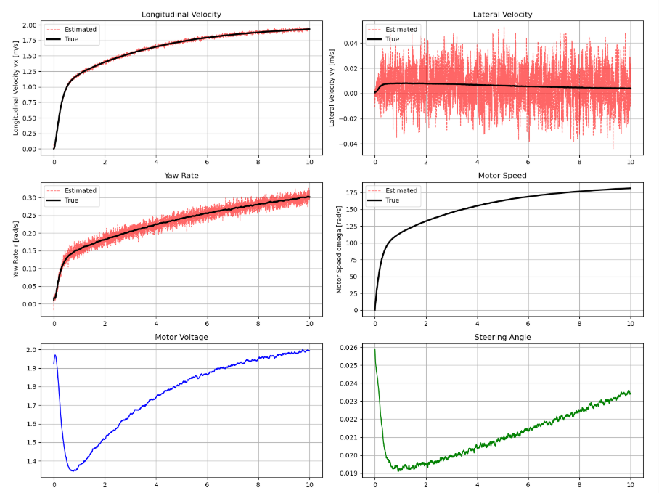
Appendix 1
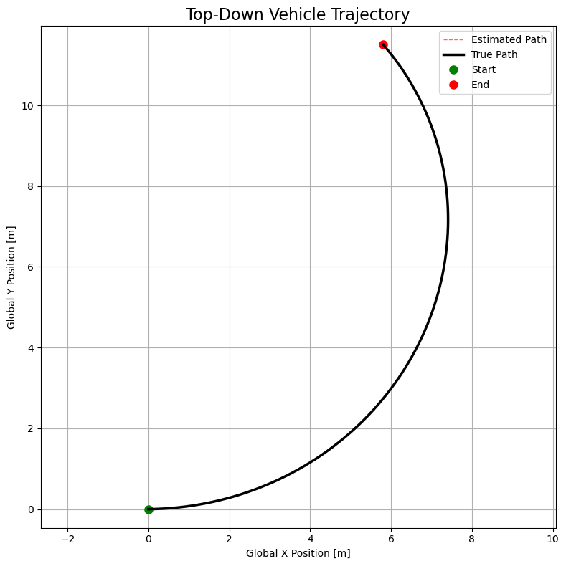
Appendix 2

A.2 Version 2 — Straight-Line Lane Keeping (Final)
Key changes from Version 1: ψref = 0.0 rad, R = diag([0.05, 0.05, 0.02, 0.1])², covariance symmetry correction P ← (P + PT)/2 added after each CKF update. All other parameters unchanged.

import numpy as np
import matplotlib.pyplot as plt
from scipy.linalg import cholesky

class CarParams:
def __init__(self):
self.m = 1.0 # Mass [kg]
self.Iz = 0.004 # Yaw Inertia [kg m^2]
self.Jm = 0.0004 # Drive-train Inertia [kg m^2]
self.lf = 0.075 # CG to front axle [m]
self.lr = 0.075 # CG to rear axle [m]
self.Cf = 30.0 # Front Cornering Stiffness [N/rad] (Lowered for stability)
self.Cr = 30.0 # Rear Cornering Stiffness [N/rad] (Lowered for stability)
self.Cx = 15.0 # Longitudinal Stiffness [Ns/m]
self.Cd = 1.0 # Drag Coefficient
self.Af = 0.03 # Frontal Area [m^2]
self.rho = 1.225 # Air Density [kg/m^3]
self.rw = 0.032 # Wheel Radius [m]
self.Ng = 3.0 # Gear Ratio
self.Rm = 0.1 # Motor Resistance [Ohm]
self.Kt = 0.01 # Torque Constant [Nm/A]
self.Ke = 0.01 # Back EMF Constant [Vs/rad]
self.bm = 0.00009 # Viscous Friction [Ns/m]
self.Va_max = 12.0 # Max Voltage [V]

def vehicle_dynamics(x, u, p):
vx, vy, r, omega = x
delta, Va = u
Va = np.clip(Va, -p.Va_max, p.Va_max)

# Smooth blending to prevent division by zero
v_blend = max(abs(vx), 0.1)

# Use arctan2 for mathematical stability
alpha_f = delta - np.arctan2((vy + p.lf * r), v_blend)
alpha_r = -np.arctan2((vy - p.lr * r), v_blend)

F_yf = p.Cf * alpha_f
F_yr = p.Cr * alpha_r
slip_speed = (p.rw * omega / p.Ng) - vx
F_xr = p.Cx * slip_speed
F_drag = 0.5 * p.rho * p.Cd * p.Af * (vx**2) * np.sign(vx)

i_a = (Va - p.Ke * omega) / p.Rm
Tm = p.Kt * i_a
T_load = (p.rw / p.Ng) * F_xr

dvx = (1.0/p.m)*(F_xr - F_drag - F_yf*np.sin(delta)) + vy*r
dvy = (1.0/p.m)*(F_yf*np.cos(delta) + F_yr) - vx*r
dr = (1.0/p.Iz)*(p.lf*F_yf*np.cos(delta) - p.lr*F_yr)
domega = (1.0/p.Jm)*(Tm - p.bm*omega - T_load)

return np.array([dvx, dvy, dr, domega])

class CKF:
def __init__(self, x0, P0, Q, R, dt, params):
self.x = x0; self.P = P0; self.Q = Q; self.R = R
self.dt = dt; self.p = params; self.n = len(x0)
self.m = 2 * self.n
self.xi = np.sqrt(self.n) * np.concatenate((np.eye(self.n), -np.eye(self.n)), axis=1)

def predict(self, u):
try: S = np.linalg.cholesky(self.P)
except: S = np.linalg.cholesky(self.P + 1e-6*np.eye(self.n))
X = np.array([self.x + S @ self.xi[:,i] for i in range(self.m)]).T
X_star = np.zeros_like(X)
for i in range(self.m):
k1 = vehicle_dynamics(X[:,i], u, self.p)
k2 = vehicle_dynamics(X[:,i]+0.5*self.dt*k1, u, self.p)
k3 = vehicle_dynamics(X[:,i]+0.5*self.dt*k2, u, self.p)
k4 = vehicle_dynamics(X[:,i]+self.dt*k3, u, self.p)
X_star[:,i] = X[:,i] + (self.dt/6)*(k1+2*k2+2*k3+k4)
x_pred = np.mean(X_star, axis=1)
P_pred = self.Q.copy()
for i in range(self.m):
d = (X_star[:,i]-x_pred).reshape(-1,1)
P_pred += (1/self.m)*(d@d.T)
self.x = x_pred; self.P = P_pred

def update(self, z):
try: S = np.linalg.cholesky(self.P)
except: S = np.linalg.cholesky(self.P + 1e-6*np.eye(self.n))
X = np.array([self.x + S @ self.xi[:,i] for i in range(self.m)]).T
Z = X.copy()
z_pred = np.mean(Z, axis=1)
Pzz = self.R.copy(); Pxz = np.zeros((self.n,self.n))
for i in range(self.m):
zd = (Z[:,i]-z_pred).reshape(-1,1)
xd = (X[:,i]-self.x).reshape(-1,1)
Pzz += (1/self.m)*(zd@zd.T)
Pxz += (1/self.m)*(xd@zd.T)
K = Pxz @ np.linalg.inv(Pzz)
self.x = self.x + K @ (z - z_pred)
self.P = self.P - K @ Pzz @ K.T
self.P = (self.P + self.P.T) / 2 # Force symmetry to prevent Cholesky crashes

class PIController:
def __init__(self, Kp, Ki, limit=None):
self.Kp=Kp; self.Ki=Ki; self.integrator=0.0; self.limit=limit

def update(self, error, dt):
self.integrator += error * dt
if self.limit:
if self.integrator*self.Ki > self.limit:
self.integrator = self.limit/self.Ki
elif self.integrator*self.Ki < -self.limit:
self.integrator = -self.limit/self.Ki
out = self.Kp*error + self.Ki*self.integrator
if self.limit: out = np.clip(out, -self.limit, self.limit)
return out

def run_simulation():
p = CarParams()
# 1. FIXED: Set dt back to 0.001 for RK4 stability
dt = 0.001; T = 10.0; steps = int(T/dt)
time_array = np.linspace(0, T, steps)

x_true = np.array([0.0, 0.0, 0.0, 0.0])
Q = np.diag([0.01, 0.01, 0.01, 0.05])**2
R = np.diag([0.05, 0.05, 0.02, 0.1])**2
ckf = CKF(x_true.copy(), np.eye(4)*0.1, Q, R, dt, p)

long_pi = PIController(Kp=1.0, Ki=0.5, limit=p.Va_max)
# 2. FIXED: Lowered lat_pi gains to stop the steering oscillation
lat_pi = PIController(Kp=0.05, Ki=0.005, limit=0.5)

v_ref = 2.0; psi_ref = 0.0
hist = {'t':[], 'x_true':[], 'x_est':[], 'u':[]}

u = np.array([0.0, 0.0])
alpha = 0.02 # Actuator smoothing factor

for k in range(steps):
z = x_true + np.random.multivariate_normal(np.zeros(4), R)
ckf.predict(u); ckf.update(z); x_est = ckf.x

# Calculate raw PI commands
Va = long_pi.update(v_ref - x_est[0], dt)
delta = lat_pi.update(psi_ref - x_est[2], dt)

# 3. FIXED: Smoothing logic correctly placed INSIDE the loop
if k == 0:
u = np.array([delta, Va])
else:
u = (1 - alpha) * u + alpha * np.array([delta, Va])

proc = np.random.multivariate_normal(np.zeros(4), Q)
k1=vehicle_dynamics(x_true,u,p)
k2=vehicle_dynamics(x_true+0.5*dt*k1,u,p)
k3=vehicle_dynamics(x_true+0.5*dt*k2,u,p)
k4=vehicle_dynamics(x_true+dt*k3,u,p)
x_true = x_true + (dt/6)*(k1+2*k2+2*k3+k4) + proc*dt

hist['t'].append(time_array[k])
hist['x_true'].append(x_true.copy())
hist['x_est'].append(x_est.copy())
hist['u'].append(u.copy())

return hist
if __name__ == '__main__':
h = run_simulation()
t = np.array(h['t'])
xt = np.array(h['x_true'])
xe = np.array(h['x_est'])
u = np.array(h['u'])

fig, axs = plt.subplots(3, 2, figsize=(14, 12))
fig.suptitle('CKF + PI Control Simulation (1/18 Scale FSD Car)', fontsize=16)
labels = ['Longitudinal Velocity vx [m/s]', 'Lateral Velocity vy [m/s]',
'Yaw Rate r [rad/s]', 'Motor Speed omega [rad/s]']
titles = ['Longitudinal Velocity Tracking', 'Lateral Velocity Estimation',
'Yaw Rate Estimation', 'Motor Speed Estimation']

for i, ax in enumerate(axs.flat[:4]):
# 1. Plot the noisy estimate FIRST, make it thinner, and make it 40% transparent (alpha=0.6)
ax.plot(t, xe[:,i], 'r--', lw=1.0, alpha=0.6, label='Estimated')

# 2. Plot the True state SECOND, make it thicker (lw=2.5), and force it to the front (zorder=5)
ax.plot(t, xt[:,i], 'k-', lw=2.5, zorder=5, label='True')

ax.set_ylabel(labels[i]); ax.set_title(titles[i])
ax.grid(True); ax.legend()

axs[2,0].plot(t, u[:,1], 'b-', lw=1.5)
axs[2,0].axhline(12, color='k', ls=':', alpha=0.5)
axs[2,0].set_ylabel('Va [V]'); axs[2,0].set_title('Motor Voltage')
axs[2,0].grid(True)

axs[2,1].plot(t, u[:,0], 'g-', lw=1.5)
axs[2,1].set_ylabel('delta [rad]'); axs[2,1].set_title('Steering Angle')
axs[2,1].grid(True)

plt.tight_layout(); plt.savefig('ckf_results.png', dpi=150); plt.show()
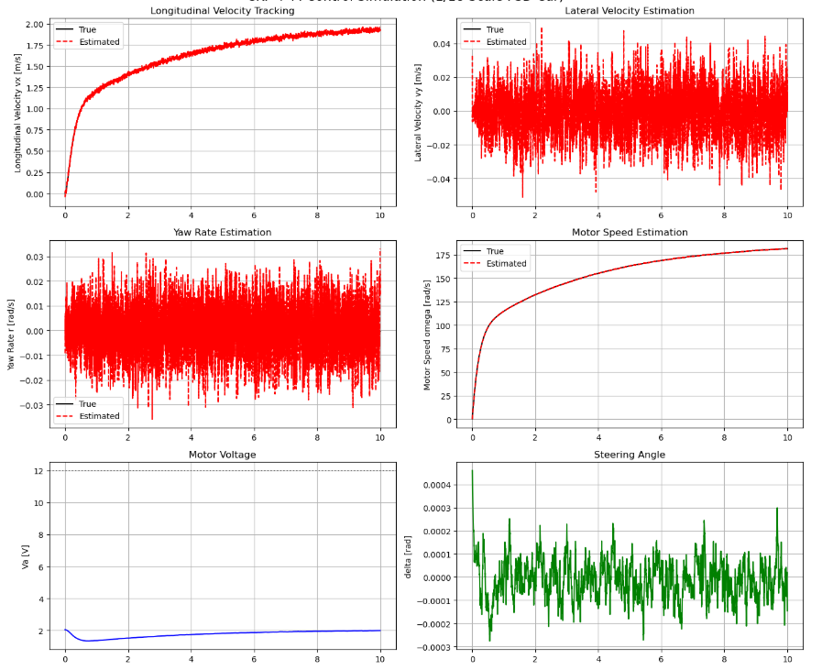
Appendix 3
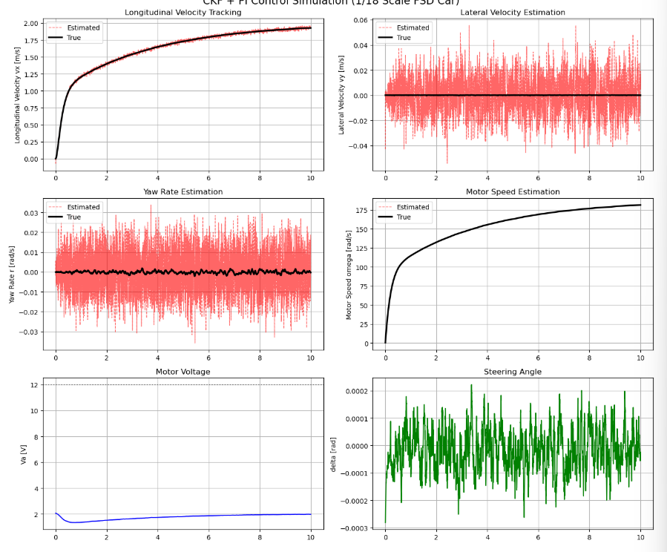
Appendix 4

